2024 RCBO COLORING CONTEST

Name: (Please Print) ___________________________________________________

Age: ___________________ Phone Number: ________________________________

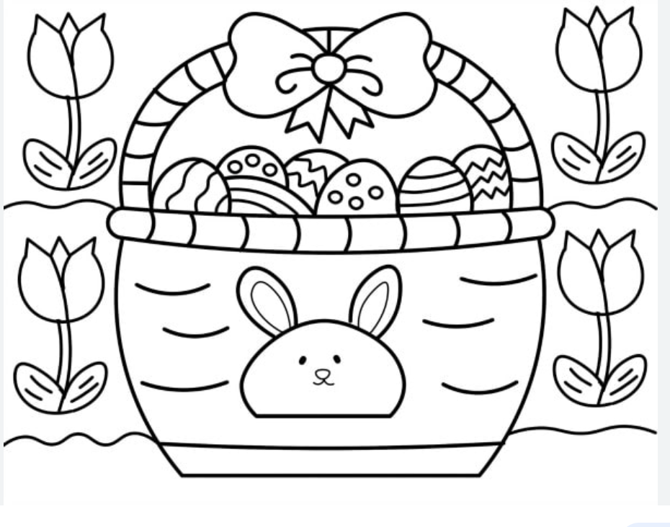
Must be mailed by March 17th to: RCBO Coloring Contest
PO Box 217
Franksville, WI 53126
Creativity Judged by Non-Members 3 age categories (3/4 5/6/7 8/9/10 )

