2026 RCBO COLORING CONTEST

Name: (Please Print) ___________________________________________________

Age: ___________________ Phone Number: ________________________________

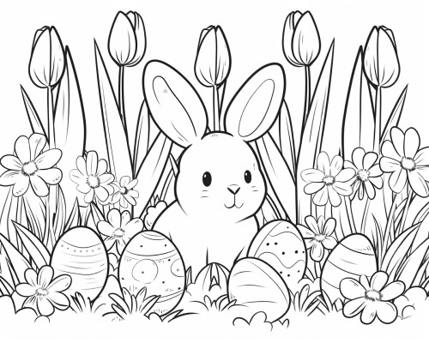

Must be mailed by March 22nd to: RCBO Coloring Contest
PO Box 217
Franksville, WI 53126
Creativity Judged by Non-Members: 3 age categories (3/4) (5/6/7) (8/9/10)

